Low Level Design (view item module)

Project Code | Team6
Project Name | Media Composer and Artist Management System

Prepared/Modified by | Role | Date of Preparation
Raunak Agarwal | Senior Software Engineer | 13/11/2017
Reviewed by | Role | Date of Review
Vaishali Srivastava | Analyst | 14/11/2017
Approved by | Role | Date of Approval
Vishal Mali | Senior Analyst
Circulation List | raunak.agarwal@capgemini.com  shubham.ayush@capgemini.com  saptarshi.saha@capgemini.com  pratik.sahoo@capgemini.com  vaishali.srivastava@capgemini.com  vishal.mali@capgemini.com | Version Number of the template:1.0
Version Number | 1.3

Table of Contents

1. Description Of The Unit 3
2. References 4
3. Dependencies / Assumptions 5
4. Class Diagrams 6
5. Sequence Diagrams 7
6. Design Components 8
6.1 List Of UI Components 8
6.2 List Of Design Classes 8
7. Re-Usable Routines/Components 9
8. Messages 10
9. Configuration Files 11
10. Crud Matrix Table 12
11. Data Mapping Matrix 13
12. Action Flow Matrix 14
13. Stored Procedures 15
14. Program Specification / Pseudo Code 16
REVISION HISTORY OF THE WORK PRODUCT 17

Description Of The Unit

The View Item module is basically used by the admin of the system, to view the existing composers in the database.

On clicking the composers Menu page, the admin will be navigated to the page where all the composers along with their details can be viewed and by selecting a composer the admin can either delete or modify a composer it.

References

Reference | Description
Repository reference | https://github.com/pratik77/plp
Class Diagram | /Project Documents/Design Documents/HLD/Class Diagrams
URS | /Project Documents/Requirements/Media Presentation Document.doc
UTP | /Project Documents/Test Plan/UTP/Test Cases/ViewComposer/UTP_ViewComposerModule.xlsm
DB Design | /Project Documents/Design Documents/HLD/DB Design/MediaComposerSystem_Group6_DBDESIGN.xls

Dependencies / Assumptions

Assumptions:
Valid details of the composer should be stored in the database.

Class Diagrams

Class Diagram

Sequence Diagrams

Sequence Diagram
NA

Design Components

List Of UI Components

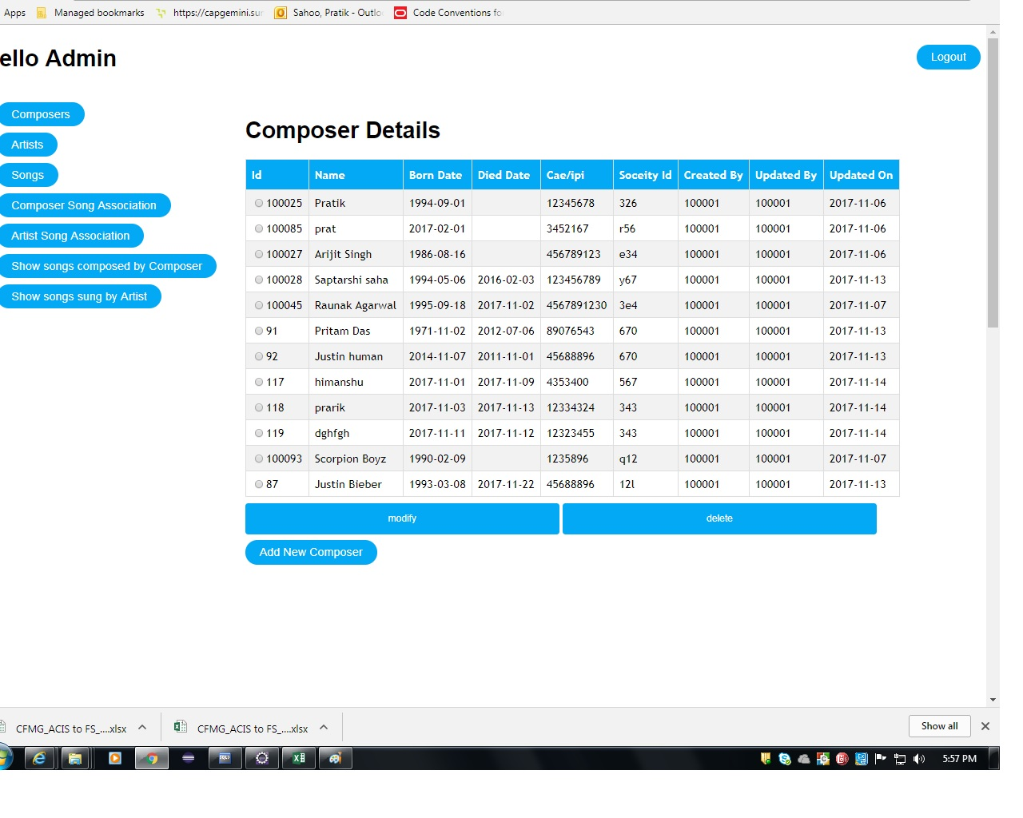

List Of Design Classes
Sr. No. | LLD Name | Class Name | Method Name | Method Description
1 | View Composer List Module | ComposerMasterDTO | Appropriate getters and setters methods | Getters retrieve the property values and setters set the property values
2 | View Composer List Module | MediaController | composerSelect(Model model): String | Get the appropriate composer details from the Menu Page and set the data into Composer lIst and add these data to the model attribute.  Controller then navigates to the retrieve all composer page which shows the description of that composer.
3 | View Composer List Module | MediaService | loadAllComposer() : List | Calls loadAllComposer() of MediaDAOImpl class and returns the Composer details to controller.
4 | View Composer List Module | MediaDAOImpl | loadAllComposer() : List | Retrieves the composer details from database and returns the Composer List to MediaServiceImpl.

Re-Usable Routines/Components

Re-Usable Routines/Components

- CSS files
- Javascript files
- DataAccessException class
- Database properties files
- Logger properties files

Messages

No messages to display.

Configuration Files

File Name | Path | Description
oracle.properties | /Development/Source | To configure database connection.
Web.xml | /Development/Source | To configure the bean properties.
Dispatcher-servlet.xml | /Development/Source | To configure the request mapping and view resolver.
logger.properties | /Development/Source | To configure the logger.
error.properties | /Development/Source | To configure error messages.
JPAContext.xml | /Development/Source | To configure the datasource, entity manager factory and transaction manager.

Crud Matrix Table

# | Table Name | Create | Read | Update | Delete
1 | Composer_Master | N | Y | N | N

Data Mapping Matrix

Sr. No. | Screen Label | Field Source | Field Type | Data Type | Max Length | Data Flow | Mandatory
1 | Composer Name | NA | Label | NA | NA | UI | NA
2 | composerName | ComposerMasterDTO.  Composer_Name | TextBox | Varchar2 | 50 | UI→D | Yes
3 | Composer Born Date | NA | Label | NA | NA | UI | NA
4 | composerBornDate | ComposerMasterDTO. Composer_BornDate | Date | Date | NA | UI→D | Yes
5 | Composer Died Date | NA | Label | NA | NA | D→UI | NA
6 | composerDiedDate | ComposerMasterDTO. Composer_DiedDate | Date | Date | NA | UI→D | Yes
7 | Composer Caeipi Number | NA | Label | NA | NA | UI | NA
8 | composerCaeipiNumber | ComposerMasterDTO. CaeipiNumber | TextBox | Varchar2 | 10 | UI→D | Yes
9 | Composer Music Id | NA | Label | NA | NA | UI | NA
10 | composerMusicSocId | ComposerMasterDTO. MusicSocietyId | TextBox | Char | 3 | UI→D | Yes
11 | Add Composer | NA | Link | NA | NA | UI | NA
12 | Modify Composer | NA | Submit | NA | NA | UI | NA
13 | Delete Composer | NA | Submit | NA | NA | UI | NA | NA

Legend
D → UI (Database to User Interface)
UI → D (User Interface to Database)
UI (User Interface Only)

Action Flow Matrix

Sr. No. | Action | Description | Process
1 | On click Composers | Shows the detailed description and the list of the composers to admin. | The admin is navigated to Retrieve all composers Page.

Stored Procedures

# | Stored Procedure Name  (with Description) | Input/Out Parameters | Type | Size
1. | N/A | N/A | N/A | N/A

Program Specification / Pseudo Code

14.1 <ACTION: View_CLICK>
Pseudo Code:
- Client Side Scripting:
None

- Server Side Scripting:
BEGIN
Call composerSelect(Model model):String in MediaController Class
BEGIN
Call loadAllComposer() of MediaServiceImpl Class
BEGIN
Call loadAllComposer() of MediaDAOImpl Class
BEGIN
Create query for select records from Composer_Master
Return composer List
END
Return composer to Service Layer.
END
Return Composer List to Presentation List.
END
Navigate to RetrieveAllComposer Page.
END

REVISION HISTORY OF THE WORK PRODUCT

# | Date | Version # | Section Changed | Details of changes made | Approved By
1 | 13/11/2017 | 1.0 | LLD prepared | N/A | Vishal Mali
2 | 05/11/2017 | 1.1 | Reusable components,  Pseudo code | Reusable components added.  The pseudo code is modified as per the specified flow. | Vishal Mali
3 | 08/11/2017 | 1.2 | Reusable components,  References,  Data Mapping Matrix. | Reusable Components added.  File name with relative path is added in the references section.  The name of text boxes(screen label is changed). | Vishal Mali
4 | 09/11/2017 | 1.3 | Configuration files,UI Components | Paths of the configuration files is updated and UI components(Screen Shots) added. | Vishal Mali

